**NO SQL DATABASE FOR IMPLEMENTING E-COMMERCE APPLICATION**

*Submitted by*

***Rohit Pandey***

***Reg. No. 21352046***

***M.C.A (3rd Semester)***

*Project phase – Design phase review on 18/10/2022*

**CSCA513 - Mini Project**

*Under the guidance of*

**Dr. Pothula Sujatha**

**Associate Professor**



**DEPARTMENT OF COMPUTER SCIENCE**

**SCHOOL OF ENGINEERING AND TECHNOLOGY**

**PONDICHERRY UNIVERSITY**

**PUDUCHERRY- 605014**

**SEPTEMBER 2022**

**Tech Stacks:** JavaScript, MongoDB, Express.js, React.js & Node.js

This project is an E-commerce web application (IndiaMart) which lists various products & allows user to purchase products after logging in.

It will have a payment gateway integrated.

**Usability:**

Desktop interface

Windows 7/8/10/11 & and upcoming versions

**Block Diagram:**

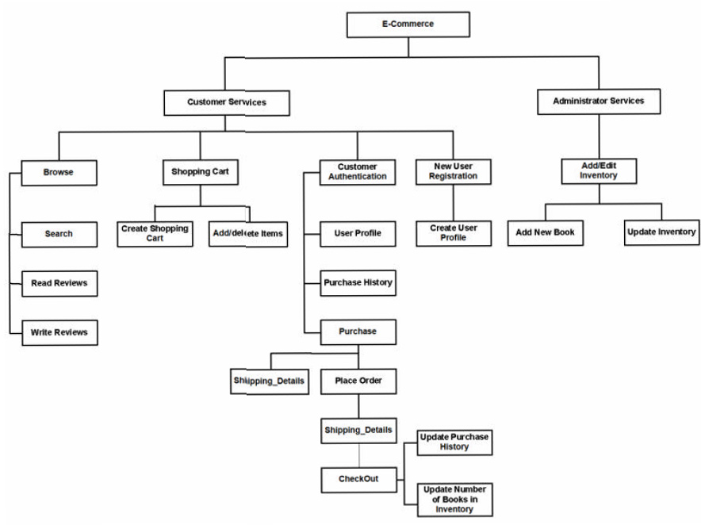

* **System Design**

### User Authentication Design

### Login

### The Log-in/sign up step is a big hurdle the user has to cross to enjoy the services of application

### login.JPG

### Registration

### We recommend representing each user with a unique user in our application. This allows you to maximize the value you get out of our access control and audit log capabilities. It also saves you the time and effort of creating and maintaining secure authentication and user management.

### reg.JPG

* **Navigation Bar Design**
* **Menu**

The menu bar provides the user with a place in a menu to find the majority of a program's essential functions.

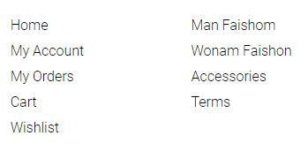

* **Search Bar**

The search bar is the location within application that lets user search anything what they want to find

**search.JPG**

* **Cart Icon**

A shopping cart is an essential part of a retailer's online store that streamlines the online shopping experience



### Building confidence

### ****Contact****

### contact.JPG

## Homepage Design

The homepage is our first chance to make a good impression, so don’t waste it. It’s the place to sell our brand to newcomers. These new visitors should be able to understand the core of our business in a matter of seconds.

High-quality pictures show professionalism and inspire trust in customers’ mind. A picture’s worth a thousand words and, since online shoppers never have the time for a thousand words, gives them pictures, lots of them.

Our homepage shouldn’t be a product listing but that doesn’t mean we can’t feature our best items on it. Think of it this way: what are the products we would showcase in our window if we had a physical shop? They can be either best sellers or featured products for specific holidays, events or seasons.

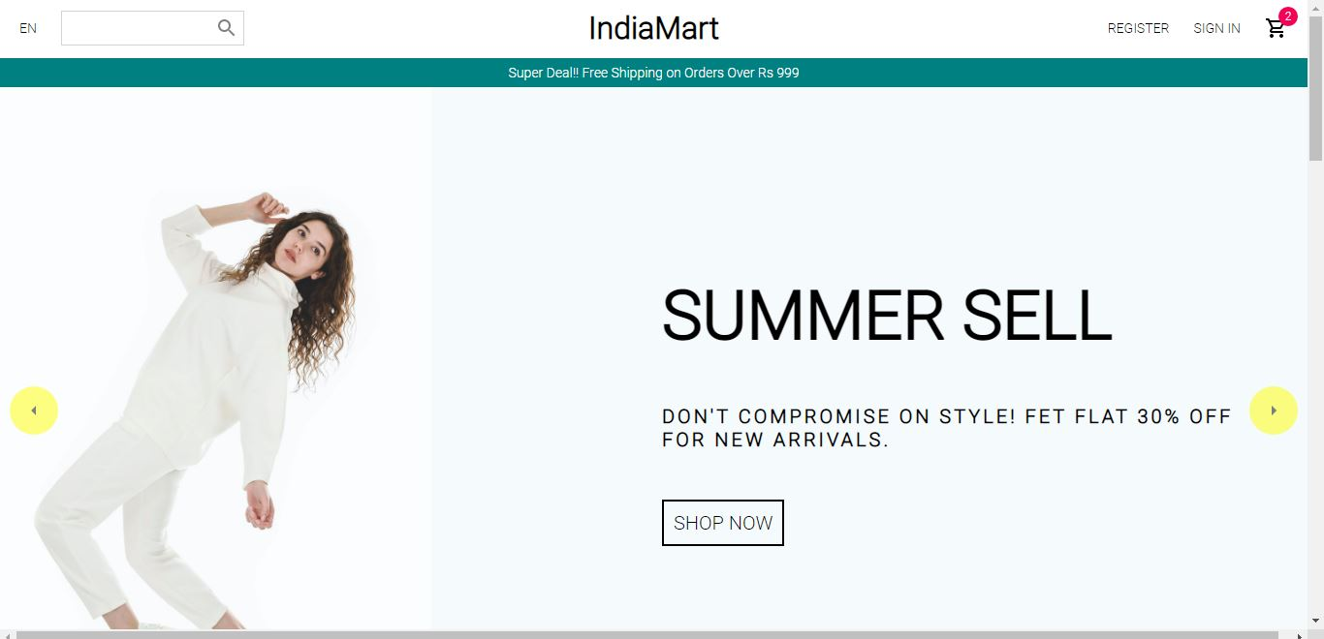

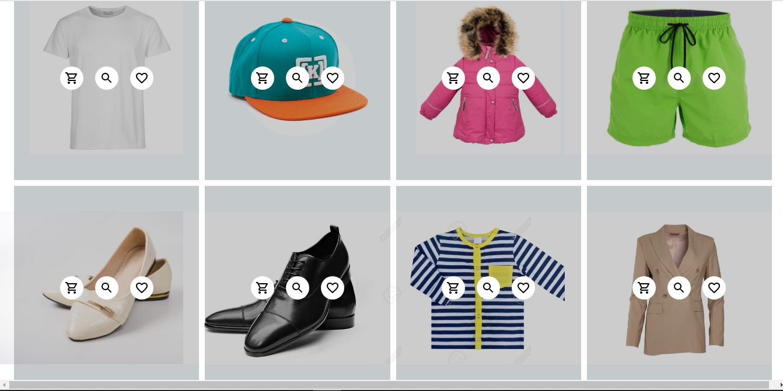

# Newsletter

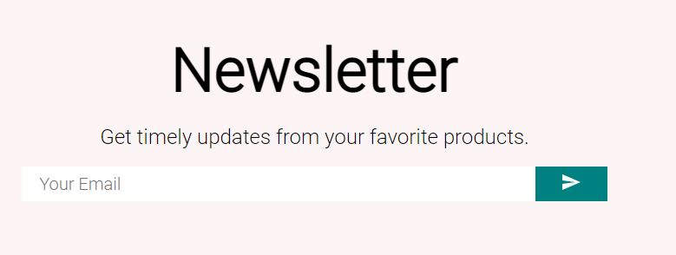

## Listing Page Design

* **Category introduction**

A short introduction to our catalogue page might help customers know immediately if they are at the right place to find what they are looking for. We can’t afford to make them waste time searching unsuccessfully, so be clear and transparent in our category introduction.

## Product Page Design

To ease that passage to the next step, this page needs to be as close as a real shopping experience as possible. This means photos, descriptions and specifications should be detailed enough so a customer feels confident to put his money on it and get what he’s paying for.

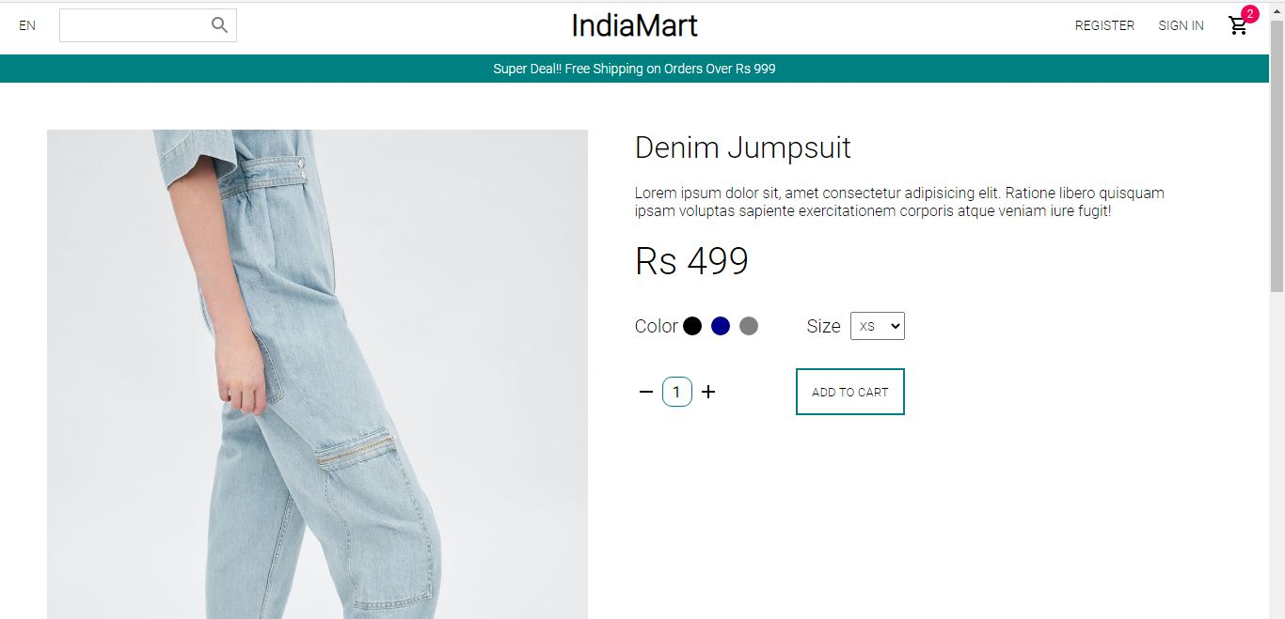

### Order place/checkout

### orderplace.JPG

### Database

### In an e-commerce application, the main purpose of a database is to store information for retrieving the product details, customer information, track transactions, and further, maintain the inventory. One of the biggest benefits of using a database for e-commerce is structuring vast amounts of shop data.

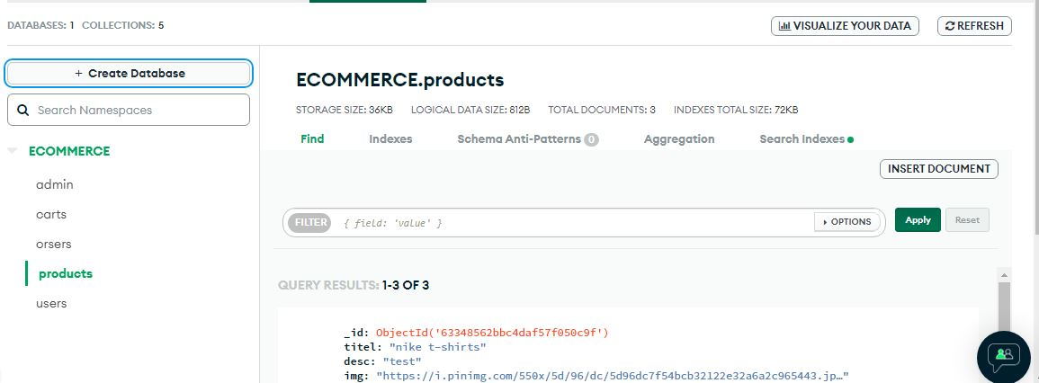

**_____________________**

Mentor In-Charge

**Dr. Pothula Sujatha**

Associate Professor

Department of Computer Science,

School of Engineering & Technology,

Pondicherry University